Step 1: Install the ESP-IDF (v5.2.1) Extension for VS Code
- Launch VS Code on your computer.
- Press Ctrl+Shift+X (Cmd+Shift+X on macOS) to open the Extensions view, or click on the Extensions icon located in the left sidebar of VS Code.
- In the Extensions search bar, type ESP-IDF.
- Find ESP-IDF by Espressif Systems and click Install.

Step 2: Install ESP-IDF Tools
- Press Ctrl+Shift+P (Cmd+Shift+P on macOS) to open the Command Palette.
- Type ESP-IDF: Configure ESP-IDF extension and select it from the list. This command will guide you through the process of downloading and installing the required tools.
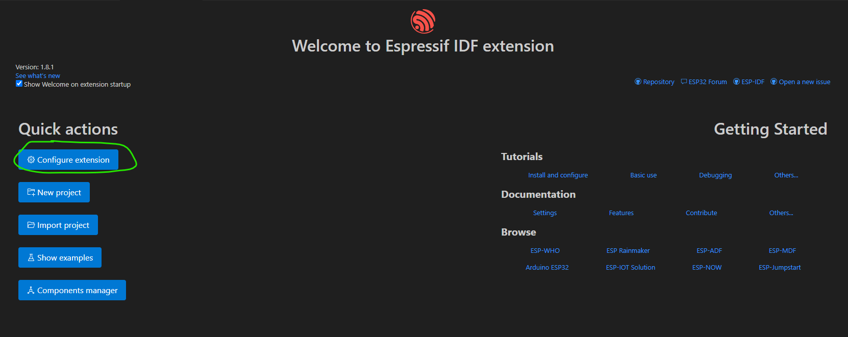
- When prompted, select a directory where the ESP-IDF tools will be installed (e.g., C:\esp-idf or a directory of your choice).
- The extension will ask to install Python dependencies and other necessary tools. Follow the prompts to install Python packages, Git, CMake, Ninja, and other dependencies required for ESP-IDF development
- Once the installation is complete, you can verify that everything is set up correctly by opening a new terminal in VS Code and typing
  - idf.py –version

Step 3: Installation Of PlatformIO IDE(v3.3.3)
- Install PlatformIO IDE from the extension of VS Code. PlatformIO IDE will automatically install in VS Code and may prompt you to reload or restart vs-code after installation.
- Once the installation is complete, you can open PlatformIO IDE from within Visual Studio Code.
- Press Ctrl+Shift+P (or Cmd+Shift+P on macOS) to open the Command Palette. Type PlatformIO: Home and select it. Alternatively, you can also open the PlatformIO Home by clicking the PlatformIO icon (alien head) in the left sidebar of VS Code.
- Once PlatformIO is installed and running, you can set up your project.
- In PlatformIO Home, click on Open Project SlimeVR-Tracker-ESP-main.
- Update the board in platformio.ini file

[env:seeed_xiao_esp32c3]
platform = espressif32
board = seeed_xiao_esp32c3
upload_speed = 921600

- After updating Platformio, restart start to configure the new board.

Step 4: Compilation Process and Flashing
- After successfully adding your code, open the main.cpp file in your project. Click on tick to compile, it will take some time for compilation.
- Click on flash arrow to flash

